TESTING – Launching accuracy

Project: Design an Autonomous Robot

Task: To design an autonomous robot that is capable of navigating to a predetermined position while avoiding obstacles and firing objects at two targets. This is to be done in the shortest time possible.

Document Version Number: 4.0

Date: April 9th, 2015

Tester: Yu Chen Xu

Software Version: 1.0

Hardware Version: 5.0

Goal: The goal of this test is to evaluate the hardware version 5.0’s ability to shoot the ball further than 150cm.

Table of Contents

Purpose 3

Objectives 3

Procedure 3

Expected Results 3

Format of Output Required 4

Sample Calculations 4

Test Report 4

Conclusion 4

Action 5

Distribution 5

# Purpose

The purpose of the test is to see if the robot can shoot the ball in order to hit a target placed at around 150cm. In this week, the requirements are changed from the clients. In fact, the target zone is enlarged. Therefore, the distance travelled by the ball needs to be increased. The reason the mechanical team wants the ball to travel 150cm is that it is the optimal distance to cover most of the target area.

In this test, the hardware version used is the latest one, V5.0. A better explanation of the newest hardware version can be found in the Week 7 docs.

A testing code that can be found in the “Launching test” folder.

# Objectives

The objective of the test is to increase the launcher’s shooting distance to 150cm.

This test is a simulation of the shooting part of the competition. Since the competition will be held at an indoor place, there will not be any factors that affect the launching of ball. Therefore, it is correct to assume that doing the test in the lab room can represent well the real situation.

# Procedure

1. Place the robot at a position (0, 0) (i.e.: at an intersection of the grids).
2. Place a target of 7.5 cm radius at (0, 150)
3. Launch a Ping-Pong ball along with the loading mechanism.
4. Note the X and Y components of the landing spot.
5. Repeat step 3) and 4) 10 times.

# Expected Results

The expected result is that the ball will land near (0, 150), after flying above the wall.

The best case of the test is that the ball will land near (0, 150) with a 7.5 cm radius error in 100% of the cases. This will prove the accuracy and the exactness of the launcher. The worst case scenario of the test would be that the landing spot is more than 7.5cm far from the desired point (0, 150) in 100% of the trials.

# Format of Output Required

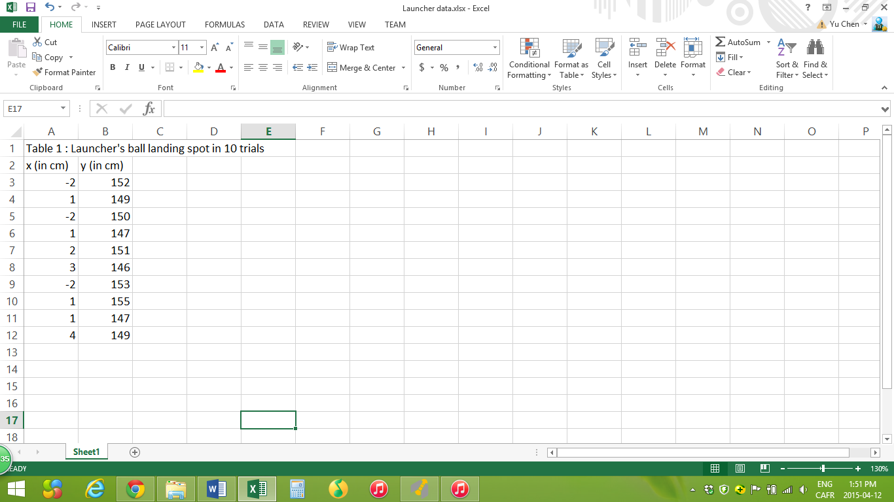

This table can be found in the “Launcher data.xlsx”.

# Sample Calculations

The mean value can be obtained by the following formula: $μ=\frac{1}{N}\sum_{i=1}^{N}{Xi}$

EX: For X-axis mean, $μ= \frac{\left(-2\right)+\left(1\right)+\left(-2\right)+…+\left(1\right)+\left(1\right)+(4)}{10}= 0.7 cm$

In this test, the mean values for x-axis and y-axis are respectively 0.7 and 149.9 cm.

The standard deviation can be obtained as $σ= \sqrt{\frac{\sum_{i=1}^{N}{({Xi-μ)}^{2}}}{N-1}}$

In this test, the standard deviation for x-axis and y-axis are respectively 2.11 and 2.88 cm.

# Test Report

The collected results are very positive as the launcher can be considered accurate, shown by the standard deviation. More importantly, the distance travelled by the ball is now increased, making the robot being able to aim most of the targets in the competition.

# Conclusion

This testing can be considered “passed” as the observed output is closed to the expected results. The launcher system is able to shoot further, at 150cm.

On each axis, the ball always landed within a 7.5 cm radius.

# Action

This test report should be keep within the mechanical team in order to bring adjustments to the launcher in the future.

# Distribution

This testing belongs to the mechanical development.